
Oesophageal Physiology Report

Dr Jafar Jafari MD, PhD, AGIP

Address: 27 Tooley St, London SE1 2PR, Telephone: 079 506 588 02, e-Mail: jafar.jafari@nhs.net __________________________________________________________________________________
Physician:
Ronald J Ede
Consultant physician and Gastroenterologist

Patient:
Ms. O'RAWE, Una E2438422

Procedure date: 02/12/2019
Procedure: High resolution manometry and 24 hour Reflux Monitoring
Indications: persistent belching and dyspepsia

Dear Dr XXXX,

Thank you for referring this pleasant lady for oesophageal physiology testing. Please see the following report and do let me know if I can be of any assistance.

Lower Esophageal Sphincter Region |  | Normal | Esophageal Motility |  | Normal
Landmarks |  |  | Number of swallows evaluated | 10
Proximal LES (from nares)(cm) | 40.2 |  | Evaluated @ 3.0 - 11.0 above LES
Distal LES (from nares)(cm) | 44.5 |  | Peristaltic (velocity ≤ 6.25 cm/s)(%) | 0
LES length(cm) | 4.3 | 2.7-4.8 | Simultaneous (vel. ≥ 6.25 cm/s)(%) | 0 | ≤10%
Esophageal length (LES-UES centers)(cm) | 24.3 |  | Failed(%) | 100 | 0%
PIP (from nares)(cm) | 42.9 |  | Evaluated @ 3.0 & 7.0 above LES
Intraabdominal LES length(cm) | 1.6 |  | Mean wave amplitude(mmHg) | 23.1 | 43-152
Hiatal hernia? | No |  | Mean wave duration(s) | 2.8 | 2.7-5.4
LES Pressures |  |  | Double-peaked waves(%) | 0 | ≤15%
Pressure meas. method | eSleeve,IRP |  | Triple-peaked waves(%) | 0 | 0%
Basal (respiratory min.)(mmHg) | 15.2 | 4.8-32.0 | Velocity (11.0-3.0 above LES)(cm/s) | 2.1 | 2.8-6.3
Basal (respiratory mean)(mmHg) | 23.3 | 13-43 | High Resolution Parameters
Residual (mean)(mmHg) | 9.0 | <15.0 | Distal contractile integral(mean)(mmHg-cm-s) | 106.8 | 500-5000
Residual (highest)(mmHg) | 10.9 |  | Distal contractile integral(highest)(mmHg-cm-s) | 106.8
Percent relaxation(%) | 66 |  | Contractile front velocity(cm/s) | 2.1 | <9.0
 |  |  | Intrabolus pressure (@LESR)(mmHg) | 1.9 | <8.4
Upper Esophageal Sphincter |  | Normal | Intrabolus pressure (avg max)(mmHg) | 11.5 | <17.0
Location (center, fr. nares)(cm) | 17.5 |  | Chicago Classification
Mean basal pressure(mmHg) | 35.5 | 34-104 | Distal latency | 6.0
Mean residual pressure(mmHg) | 7.7 | <12.0 | % failed (Chicago Classification) | 90
Relaxation time-to-nadir(ms) | 167 | 74-365 | % panesophageal pressurization | 0
Relaxation duration(ms) | 650 | 480-1020 | % premature contraction | 0
 |  |  | % rapid contraction | 0
 |  |  | % large breaks | 0
 |  |  | % small breaks | 10

HRM
Upper Oesophageal Sphincter: The UOS was and showed on wet-swallows.
Tubular oesophagus: The oesophageal body produced ; 1/10 swallows were weak, 9/10 failed.
Lower Oesophageal Sphincter: The LOS was and showed on wet-swallows. There was hiatus hernia.
Diagnosis of HRM:

24 hour pH-Impedance Reflux Monitoring:
Distal Oesophagus: total: 0.8%, normal <; upright1.5%, normal <; supine: 0.0%, normal <; DeMeester score: 3.7, normal <14.72; : total 63,
Reflux-symptom correlations: Symp1 =-----------: 17 episodes, SI=82%, SAP=100%; Symp2 =-----------: 42 episodes, SI=86%, SAP=100%; Positive SI >= 50%, Positive SAP >95%;
Conclusion of reflux monitoring: .; Both symptoms in this patient were related to normal degree of reflux (-----------).
Comment – majority of reflux events in this patient were triggered by belch (gastric type). Since there was no sign of aerophagia, it may help to rule out SIBO as an underlying cause for reflux events n this patient.

Dr. Jafar Jafari MD, PhD | Dr T Wong MD FRCP

Swallow #1  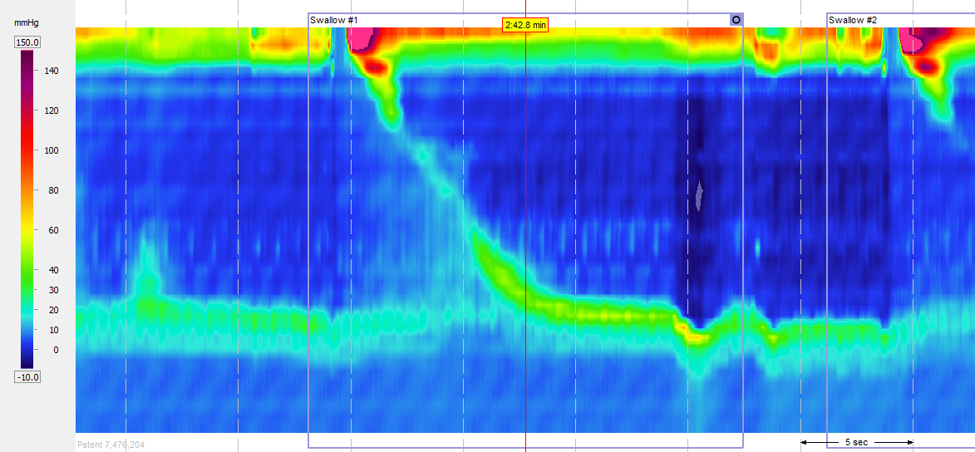 | Swallow #2  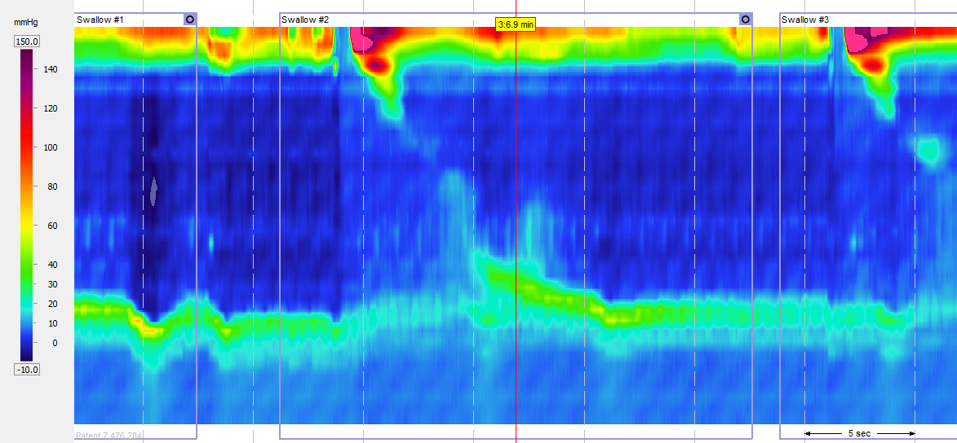
Swallow #3  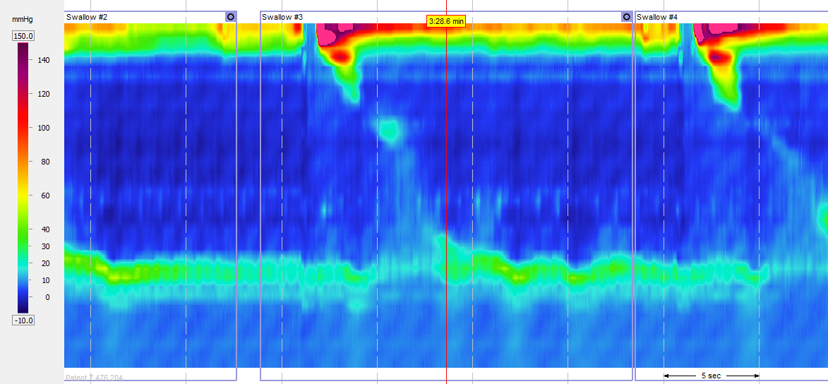 | Swallow #4  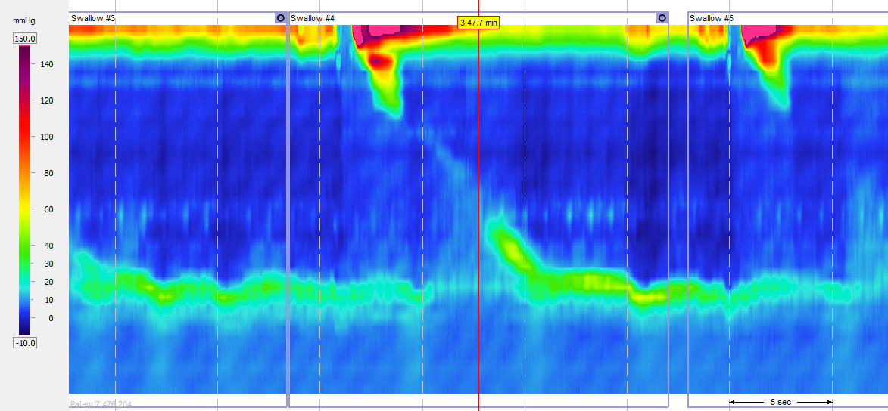
Multiple water swallows  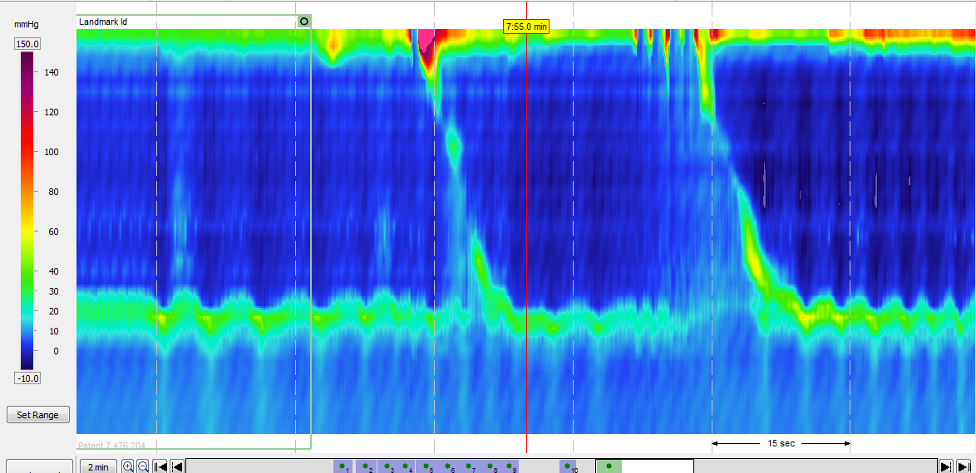 | Solid swallows  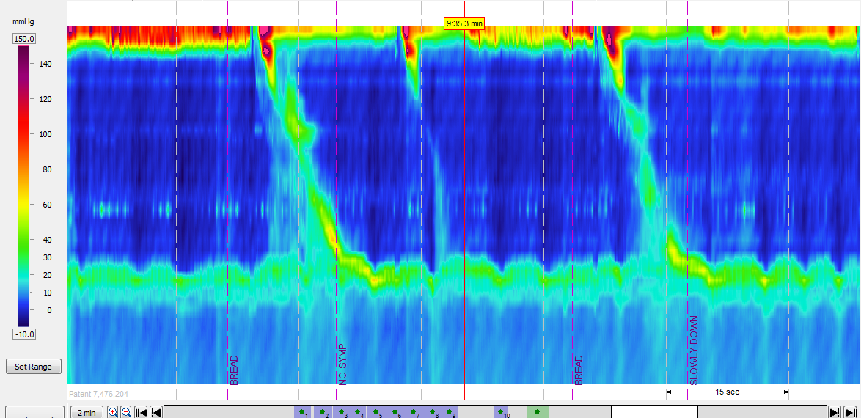
Solid swallow

